**PROBLEM SOLVING**

(Solving Various Problems With C Language & C++)

*Summer Internship Report Submitted in partial fulfillment*

*of the requirement for under graduate degree of*

**Bachelor of Technology**

In

**Computer Science Engineering**

By

Y BUJJI SAI MAHESH

**221710313064**

[**https://github.com/saimahesh16**](https://github.com/saimahesh16/problem-solving_221710313064)

*Under the Guidance of*

Assistant Professor



Department Of Electronics and Communication Engineering

GITAM School of Technology

GITAM (Deemed to be University)

Hyderabad-502329

July 2020

**DECLARATION**

I submit this industrial training work entitled **“Solving Various Problems With C Language & C++**” to GITAM (Deemed To Be University), Hyderabad in partial fulfillment of the requirements for the award of the degree of “**Bachelor of Technology**” in “**Computer Science Engineering**”. I declare that it was carried out independently by me under the guidance of **Mr. ___**, Asst. Professor, GITAM (Deemed To Be University), Hyderabad, India.

The results embodied in this report have not been submitted to any other University or Institute for the award of any degree or diploma.

Place: HYDERABAD Y Bujji Sai Mahesh

Date: 221710313064

**GITAM(Deemed To Be University)**

**Hyderabad-502329**

**Telangana, India.**

**Date:**

**CERTIFICATE**

This is to certify that the Industrial Training Report entitled **“Solving Various Problems With C Language & C++”** is being submitted by Y Bujji Sai Mahesh (221710313064) in partial fulfillment of the requirement for the award of **Bachelor of Technology** **in Computer Science Engineering** at GITAM (Deemed To Be University), Hyderabad during the academic year 2019-20

It is faithful record work carried out by him at the **Computer Science Engineering Department**, GITAM University Hyderabad Campus under my guidance and supervision.

**Mr. ___ Dr. S Phani Kumar**

Assistant Professor Professor and HOD

Department of CSE Department of CSE

**ACKNOWLEDGEMENT**

Apart from my effort, the success of this internship largely depends on the encouragement and guidance of many others. I take this opportunity to express my gratitude to the people who have helped me in the successful competition of this internship.

I would like to thank respected **Dr. N. Siva Prasad,** Pro Vice Chancellor, GITAM Hyderabad and **Dr.N.Seetharamaiah,** Principal, GITAM Hyderabad

I would like to thank respected **Dr. S. Phani Kumar,** Head of the Department of Electronics and Communication Engineering for giving me such a wonderful opportunity to expand my knowledge for my own branch and giving me guidelines to present a internship report. It helped me a lot to realize of what we study for.

I would like to thank the respected faculties **Mr. ___** who helped me to make this internship a successful accomplishment.

I would also like to thank my friends who helped me to make my work more organized and well-stacked till the end.

Y BUJJI SAI MAHESH

221710313064

# 

# 

**TABLE OF CONTENTS**

**1. INTRODUCTION TO THE PROJECT**1

**2. PROBLEM 1** **- Saving For a Rainy Day** 2

2.1 Problem Statement 2

2.2 Coding 3

2.3 OUTPUT 3

**3. PROBLEM 2** **- Reverse Gear** 4

3.1 Problem statement 4

3.2 Coding 5

3.3 OUTPUT  6

**4. PROBLEM 3** **- XTotalSpaces** 7

4.1 Problem statement 7

4.2 Coding  9

4.3 OUTPUT  10

**5. PROBLEM 4** **- Testvita** 11

5.1 Problem statement 11

5.2 Coding 13

5.3 OUTPUT  14

**6. PROBLEM 5** **- BuildingBlocks** 15

6.1 Problem Statement 15

6.2 Coding 18

6.3 OUTPUT  20

**7. PROBLEM 6** **- SuperReducedString** 21

7.1 Problem Statement 21

7.2 Coding 23

7.3 OUTPUT 23

**8. SOFTWARE REQUIREMENTS**23

8.1 Hardware Requirements 24

8.2 Software Requirements

9. **REFERENCES** 25

# 

# 1. INTRODUCTION TO THE PROJECT

Problem Solving is the Process of Designing and carrying out the certain steps to reach a Solution. Six problems which are listed below are of different complexity and require different approach and logics in order to achieve desired Output/ Solution.

1. **Saving for a rainy day** - Here, we are going to find out how much a person should deposit today so that he can get assured cash flow as per rate of interest from the given input.
2. **Reverse gear -** Here, we are going to calculate the time taken by the car to hit the wall and we have to park it correctly from the given input.
3. **X total spaces -** Here, we are going to find number of shapes in an string array N*M of O’s and the X’s and print number of shapes from the given input.
4. **Test vita -** Here, we are going to calculate the minimum number of hours required based on the dependencies from the given input.
5. **Building Blocks** -Here, we are going to calculate the number of blocks that can be piled according to the rules given by their mathematics teacher in the MxN grid from the given input.
6. **Super reduced string** - Here, we are going to reduce the string to its shortest length by performing a series of the operations and print it from the given input.

I have executed projects in C language. For the C language, I have used DEV C++ to execute the codes and questions from the TCS codevita and potential project problems.

# 

# 2. PROBLEM 1

**Saving For a Rainy Day**

In this problem we are going to find out how much a person should deposit today so that he can get assured cash flow as per rate of interest.

## 2.1 Problem Statement:-

By nature, an average Indian believes in saving money. Some reports suggest that an average Indian manages to save approximately 30+% of his salary. Ramu is one such hard working fellow. With a view of future expenses, Ramu resolves to save a certain amount in order to meet his cash flow demands in the future. Consider the following example. Ramu wants to buy a TV. He needs to pay Rs 2000/per month for 12installments to own the TV. If let's say he gets 4% interest per annum on his savings bank account, then Ramu will need to deposit a certain amount in the bank today, such that he is able to withdraw Rs 2000/per month for the next 12 months without requiring any additional deposits throughout. Your task is to find out how much Ramu should deposit today so that he gets assured

cash flows for a fixed period in the future, given the rate of interest at which his money will grow during this period.

**Input Format**:

First line contains desired cash flow M

Second line contains period in months denoted by T

Third line contains rate per annum R expressed in percentage at which deposited amount will grow

**Output Format**:

Print total amount of money to be deposited now rounded off to the nearest integer

Sample Input 1

500

3

12

Sample Output 1

1470

Sample Input 2

6000

3

5.9

Sample Output 2

17824

**Concepts Used To Solve:-**

Computations to get amount to be deposited: we use standard formulas to compute the amount to be deposited

## 2.2 Coding:-

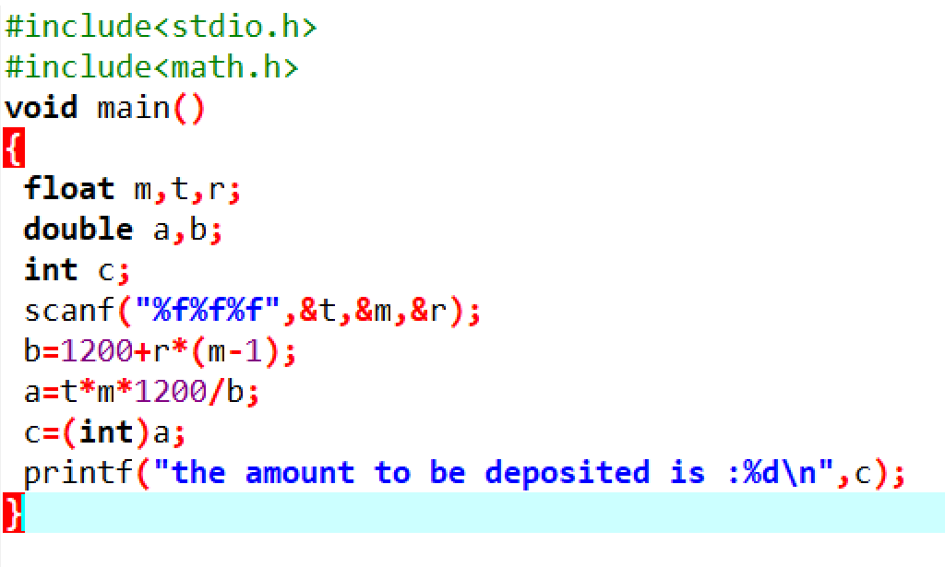

**Fig 2.2.1**

## 

## 

## 2.3 OUTPUT:

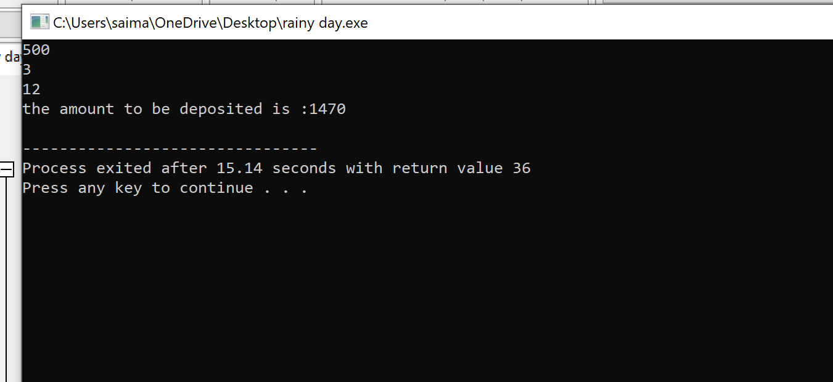

**Fig 2.3.1**

# 3. PROBLEM 2

**REVERSE GEAR**

In this problem we are going to calculate the time taken by the car to hit the wall and we have to park it correctly.

## 3.1 Problem statement:-

A futuristic company is building an autonomous car. The scientists at the company are training the car to perform Reverse parking. To park, the car needs to be able to move in backward as well as forward direction. The car is programmed to move backwards B meters and forwards again, say F meters, in a straight line. The car does this repeatedly until it is able to park or collides with other objects. The car covers 1 meter in T units of time. There is a wall after distance D from car's initial position in the backward direction. The car is currently not without defects and hence often hits the wall. The scientists are devising a strategy to prevent this from happening. Your task is to help the scientists by providing them with exact information on amount of time available before the car hits the wall.

**Input Format:**

First line contains total number of test cases, denoted by N

Next N lines, contain a tuple containing 4 values delimited by space

F B T D, where

1. F denotes forward displacement in meters

2. B denotes backward displacement in meters

3. T denotes time taken to cover 1 meter

4. D denotes distance from Car's starting position and the wall in backward direction

**Output Format:**

For each test case print time taken by the Car to hit the wall

Sample Input and Output

input Output

2 162

6 9 3 18 220

3 7 5 20

**Concepts Used To Solve:-**

Computations , while

**While** -A while loop in C programming repeatedly executes a target statement as long as a given condition is true.

**Syntax:-**

while(condition) {

statement(s);

}

**Flow chart:-**

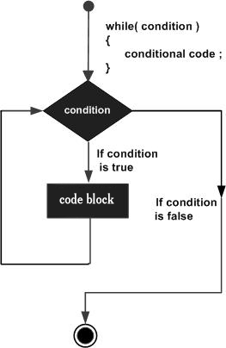

**Fig-3.1.1**

**Computations:-**

Computations to get amount to be deposited : we use standard formulas to compute the amount to be deposited

## 

## 3.2 Coding:-

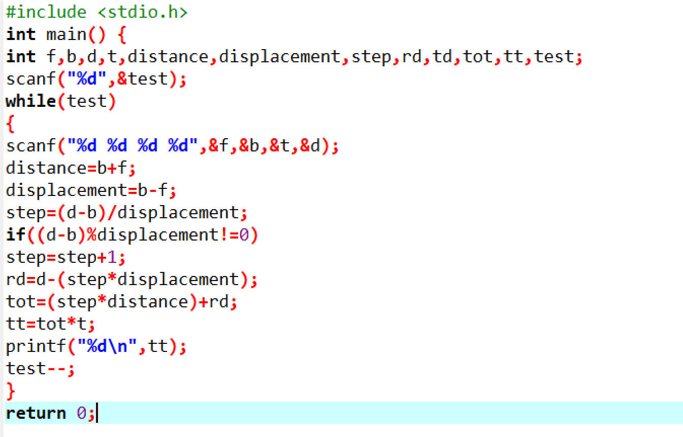

**Fig 3.2.1**

## 3.3 OUTPUT:-

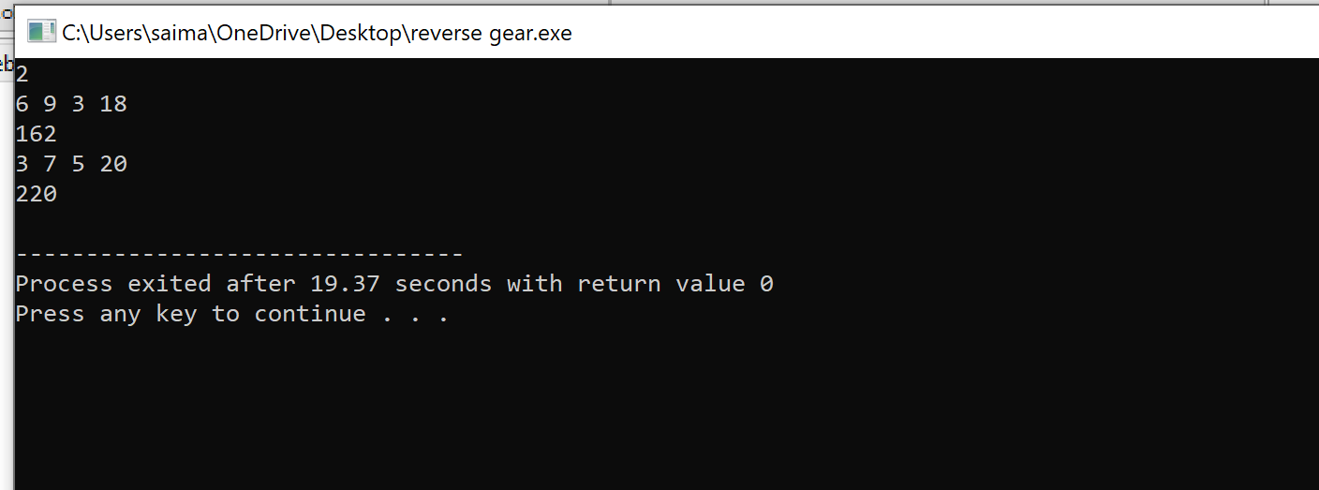

**Fig 3.3.1**

# 4. PROBLEM 3

**X TOTAL SPACES**

In this problem we are going to find number of shapes in an string array N*M of O’s and the X’s

and print number of shapes

## 4.1 Problem statement:-

Given N * M string array of O's and X's. The task is to find the number of 'X' total shapes. 'X' shape consists of one or more adjacent X's (diagonals not included).

**Input:**

The first line of input takes the number of test cases T. Then T test cases follow. Each of the T test cases takes 2 input lines. The first line of each test case have two integers N and M.The second line of N space separated strings follow which indicate the elements in the array.

**Output:**

For each testcase, print number of shapes.

**Expected Time Complexity:**

O(N*M).

**Expected Auxiliary Space:**

O(N*M) (recursive).

**Example:**

**Input:**

2

4 7

OOOOXXO OXOXOOX XXXXOXO OXXXOOO

10 3

XXO OOX OXO OOO XOX XOX OXO XXO XXX OOO

**Output:**

4

6

Explanation:

Testcase 1:

Given input is like:

OOOOXXO

OXOXOOX

XXXXOXO

OXXXOOO

So, X with same colour are adjacent to each other vertically for horizontally (diagonals not included). So, there are 4 different groups in the given matrix.

**Concepts Used To Solve:-**

Graph, DFS

**Graph-** A graph is a data structure that consists of the following two components:

**1.** A finite set of vertices also called as nodes.

**2.** A finite set of ordered pair of the form (u, v) called as edge. Graphs are used to represent many real-life applications: Graphs are used to represent networks.

Click to enlarge

**Fig 4.1.1**

DFS - Depth First Traversal (or Search) for a graph is similar to Depth First Traversal of a tree. The only catch here is, unlike trees, graphs may contain cycles, a node may be visited twice.

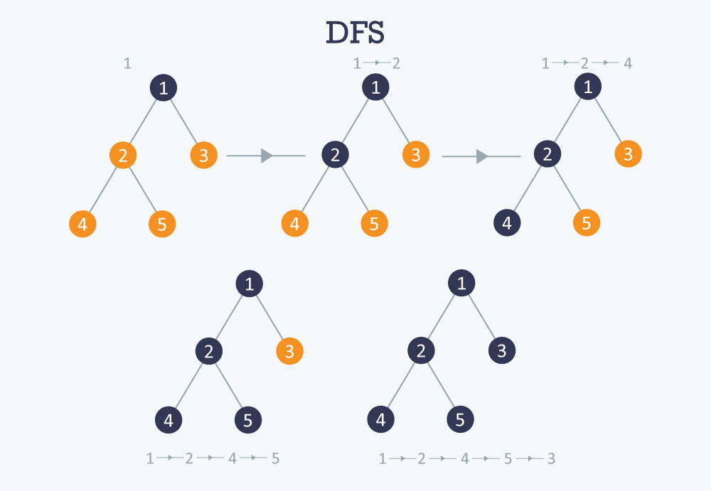

**Fig 4.1.2**

## 4.2 Coding :-

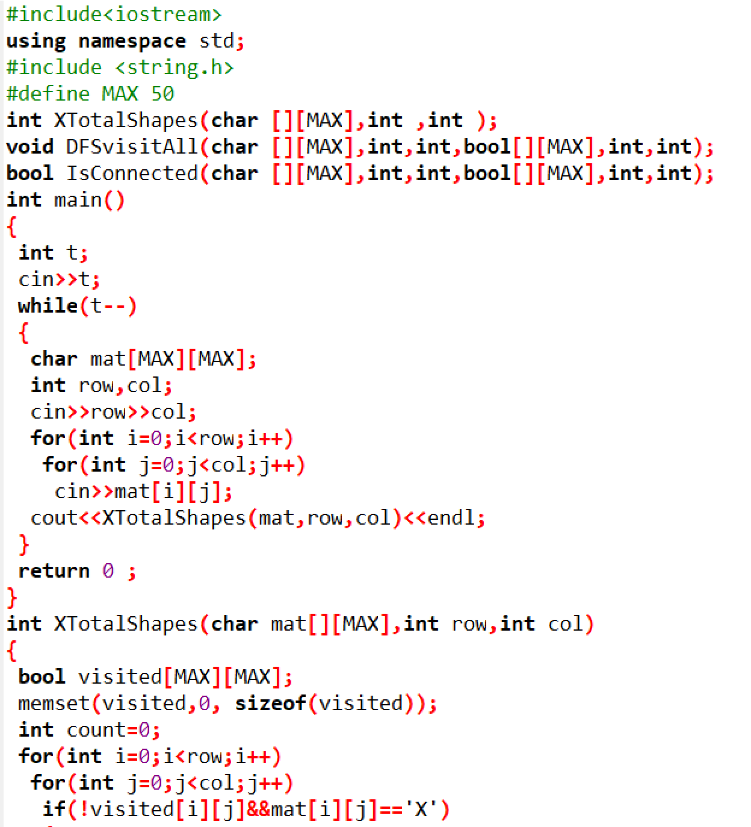

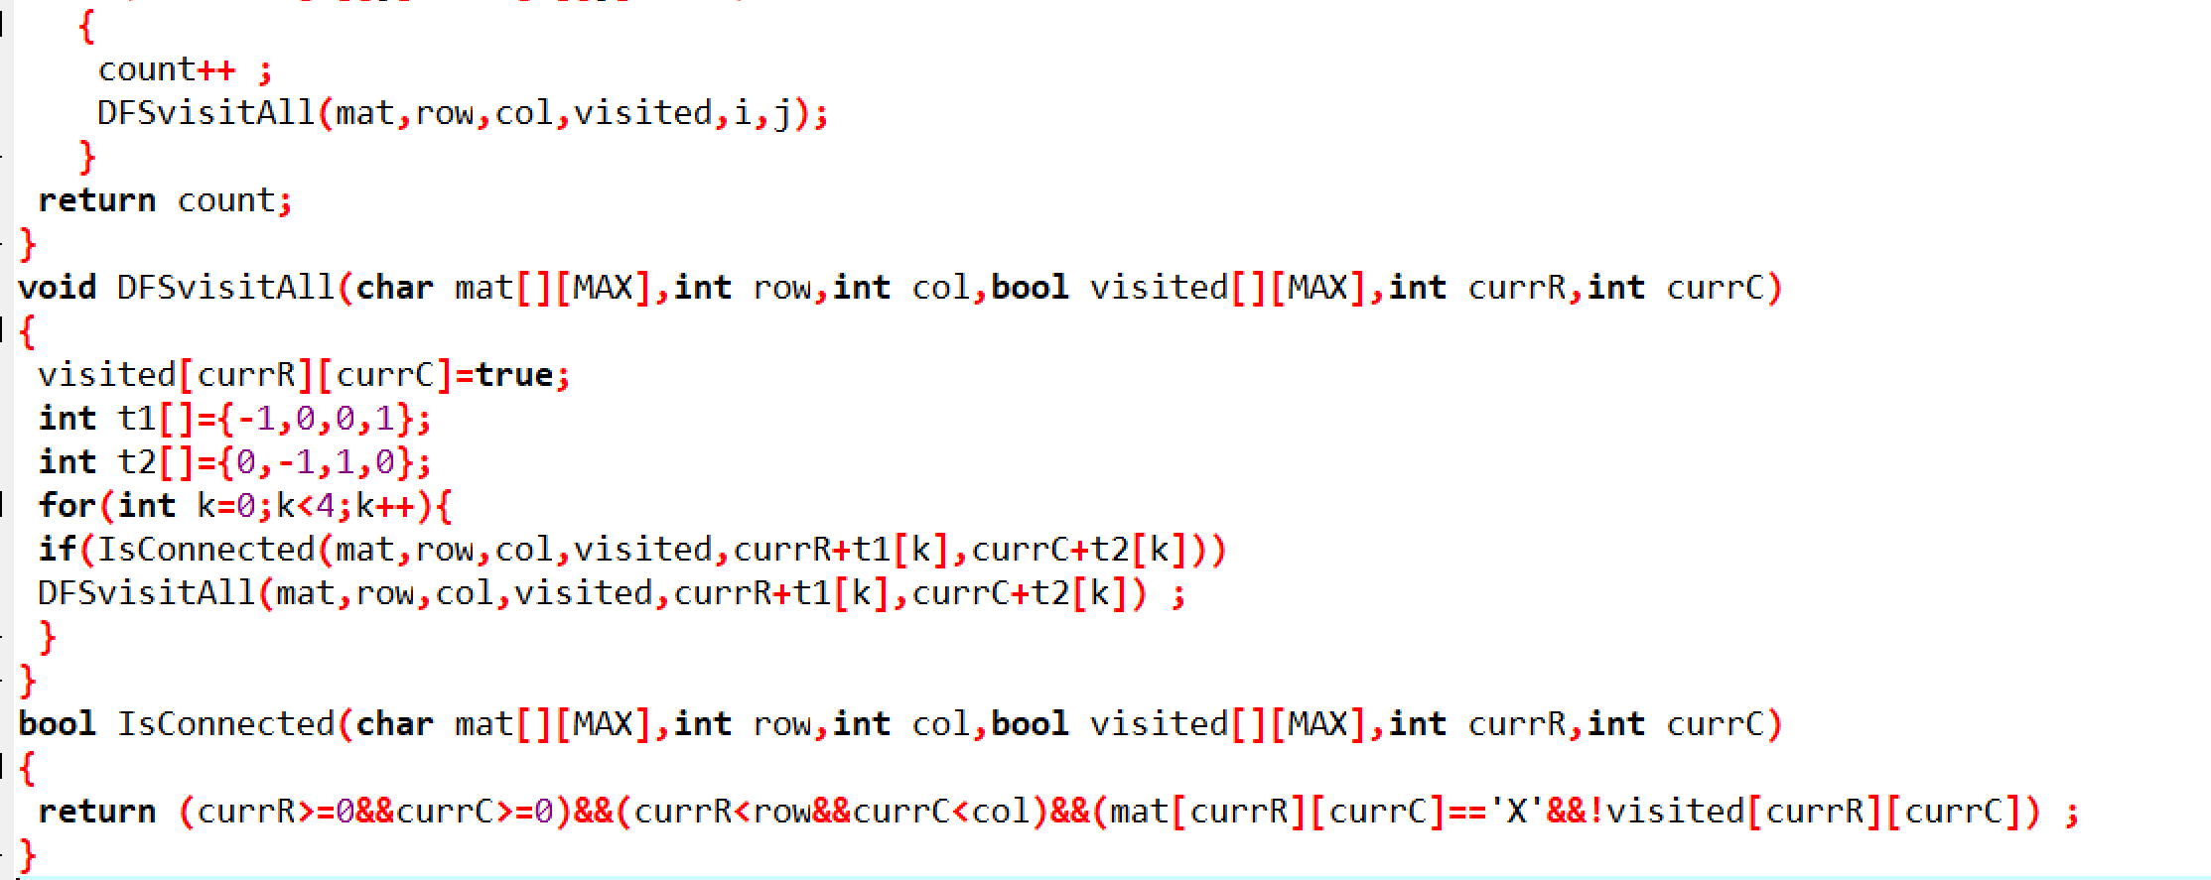

**Fig 4.2.1**

## 4.3 OUTPUT :-

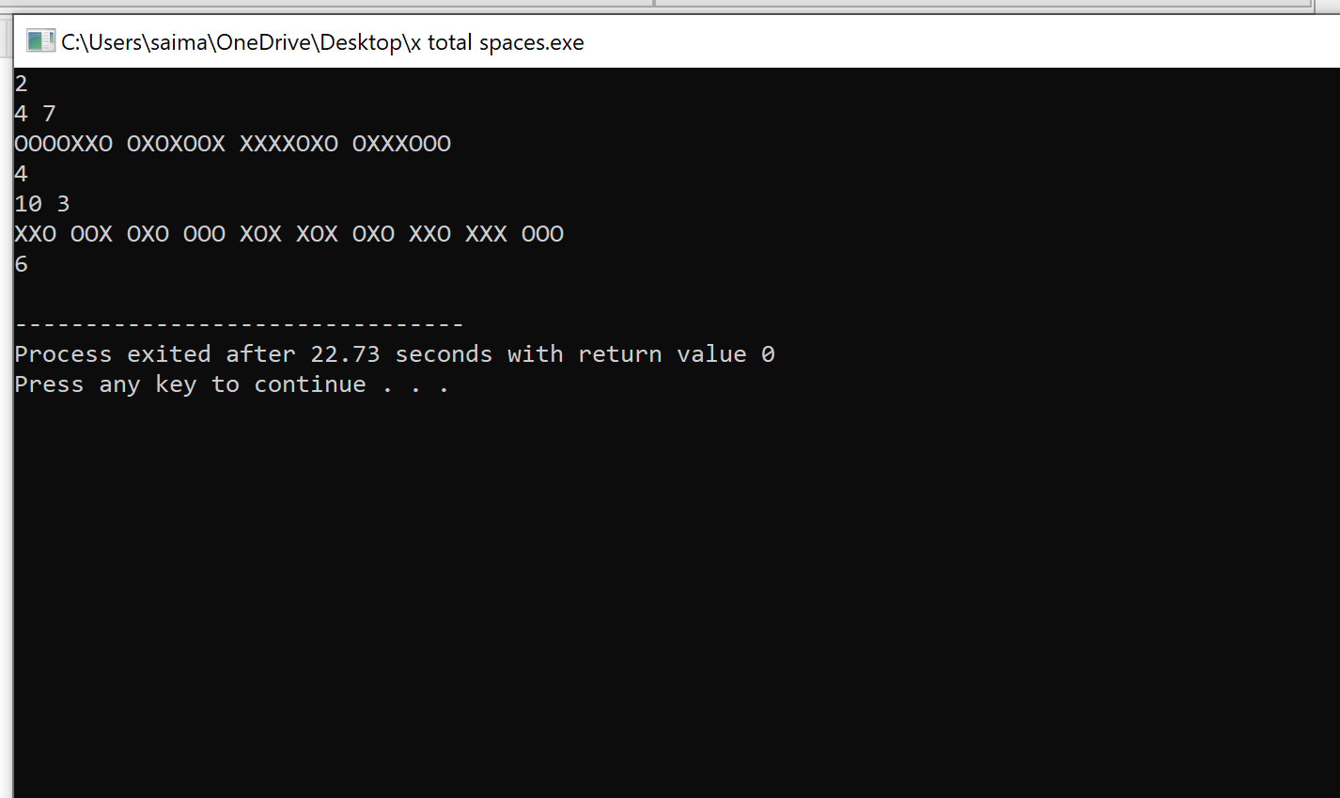

**Fig 4.3.1**

# 

# 

# 

# 

# 

# 5. PROBLEM 4

**TESTVITA**

In this problem, we are going to calculate the minimum number of hours required based on the dependencies.

## 5.1 Problem statement:-

TCS is working on a new project called "TestVita". There are N modules in the project. Each module (i) has completion time denoted in number of hours (Hi) and may depend on other modules. If Module x depends on Module y then one needs to complete y before x.

As Project manager, you are asked to deliver the project as early as possible. Provide an estimation of amount of time required to complete the project.

**Input Format:**

First line contains T, number of test cases.

For each test case:

1. First line contains N, number of modules.

2. Next N lines, each contain:

(i) Module ID

(Hi) Number of hours it takes to complete the module

(D) Set of module ids that i depends on integers delimited by space.

**Output Format:**

Output the minimum number of hours required to deliver the project.

Constraints:

1. 1 <= T <= 10

2. 0 < N < 1000; number of modules

3. 0 < i <= N; module ID

4. 0 < Hi < 60; number of hours it takes to complete the module i

5. 0 <= |D| < N; number of dependencies

6. 0 < Dk <= N; module ID of dependencies

Sample Input

1

5

1 5

2 6 1

3 3 2

4 2 3

5 1 3

Sample Output

16

**Explanation:**

Module 2 depends on module 1, hence complete module 1 first

After completing module 1 we can complete module 2 and then module 3

Module 4 and 5 can be started simultaneously in parallel after module 3 is completed.

Hence the answer = 5 + 6 + 3 + 2 = 16

**Concepts Used To Solve:-**

Loops, Array

**Loops** - A for loop is a repetition control structure which allows us to write a loop that is executed a specific number of times. The loop enables us to perform n number of steps together in one line

.

**Syntax:-**  
for ( init; condition; increment ) {

statement(s);

}

**Arrays** - An array in C or C++ is a collection of items stored at contiguous memory locations and elements can be accessed randomly using indices of an array. They are used to store similar type of elements as in the data type must be the same for all elements. They can be used to store collection of primitive data types such as int, float, double, char, etc of any particular type.

**Syntax -**

Datatype arrayName [ arraySize ];

## 5.2 Coding:-

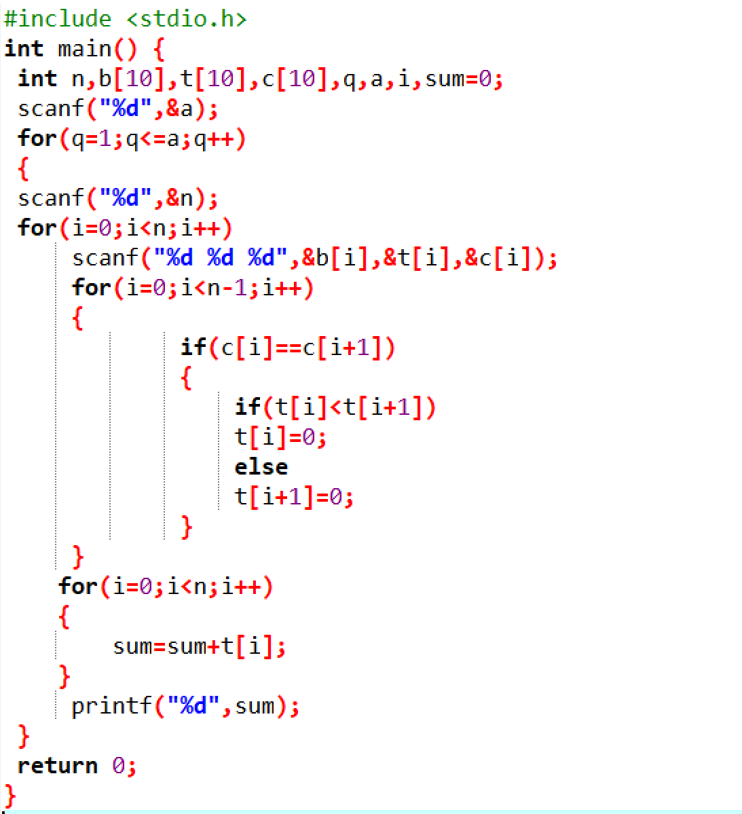

**Fig 5.2.1**

## 5.3 OUTPUT :-

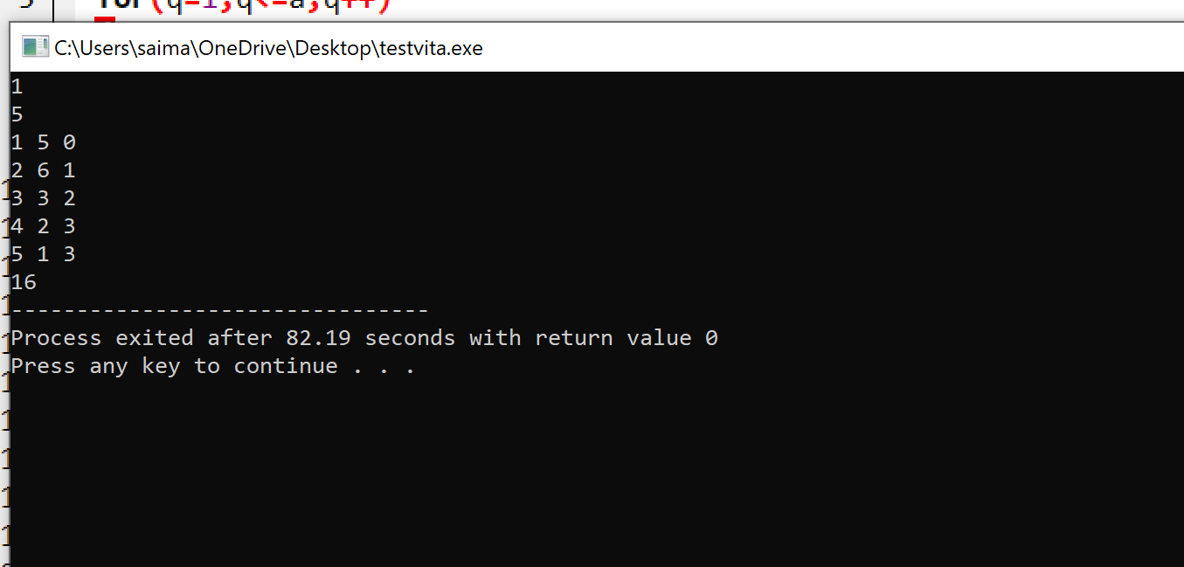

**Fig 5.3.1**

# 

# 

# 

# 6. PROBLEM 5

**BUILDING BLOCKS**

In this problem we are going to calculate number of blocks that can be piled according to the rules given by their mathematics teacher in the MxN grid

## 6.1 Problem Statement:-

The Mathematics teacher wanted to introduce a new competition to the students to sharpen their skills in optimization. He drew a rectangular M ×N grid on the ground and filled it with some non-negative integers on each cell of the grid. The cell named (i,j) is at the intersection of i th row and j th column. He gave the following challenge to the students:

1. On each cell of the grid, you can pile any number of cube blocks.

2. Each layer must be rectangular (with no gaps) and rest p supported completely by the immediate below layer.

3. The number of blocks on each cell should not exceed the number written on the cell on the ground.

4. In each layer, the cell above (1,1) must be covered.

The challenge is to pile up the maximum number of blocks subject to the above conditions.

For example if the bottom grid was as follows:

1 1 0

1 1 1

1 1 0the maximum number of blocks you can pile is 6 with one layer covering all the cells from (1,1) to (3,2).

Constraints

1 <= M,N <= 50

Maximum value in each cell is 50

**Input Format:**

The first line will contain two comma separated integers M,N giving the size of the grid, where M is the number of rows and N is the number of columns.

The next M lines will each contain comma separated N non-negative integers giving the numbers in the grid cells.

**Output:**

One line containing the number of blocks that can be piled according to the rules.

**Explanation:**

**Example 1:**

**Input:**

3,4

5,4,9,3

4,3,5,6

2,2,1,1

**Output:**

32

**Explanation:**

One example of the maximum number of blocks that could be piled on the grid is shown below:

5 4 4 3

3 3 3 3

1 1 1 1

The total number of blocks is 32. Hence the output is 32.

**Example 2:**

**Input:**

4,7

27,26,28,14,15,38,0

38,40,35,2,20,43,39

18,48,43,2,47,18,26

38,2,29,23,14,31,32

**Output:**

242

Explanation

The number of rows is 4. The number of columns is 7. The values in the cells of the grid are

27 26 28 14 15 38 0

38 40 35 2 20 43 39

18 48 43 2 47 18 26

38 2 29 23 14 31 32

One possible maximal placing of the blocks is

27 26 26 2 2 2 0

27 26 26 2 2 2 0

18 18 18 2 2 2 0

2 2 2 2 2 2 0

As there are 242 blocks in this maximal placing, the output is 242.

**Concepts Used To Solve:-**

Matrices , For

**Matrices-**

A matrix is a collection of elements of the same type, organized in the form of a table. Each element is indexed by a pair of numbers that identify the row and the column of the element. A matrix can be represented in Java through an array, whose elements are themselves (references to) arrays representing the various rows of the matrix.

**Declaration of a matrix:-**

A matrix is declared in the following way (as an array of arrays): int[][] m; // declaration of an array of arrays (matrix) m

**For** -A for loop is a repetition control structure which allows us to write a loop that is executed a specific number of times. The loop enables us to perform n number of steps together in one line.

**Syntax:-**  
for ( init; condition; increment ) {

statement(s);

}

## 6.2 Coding:-

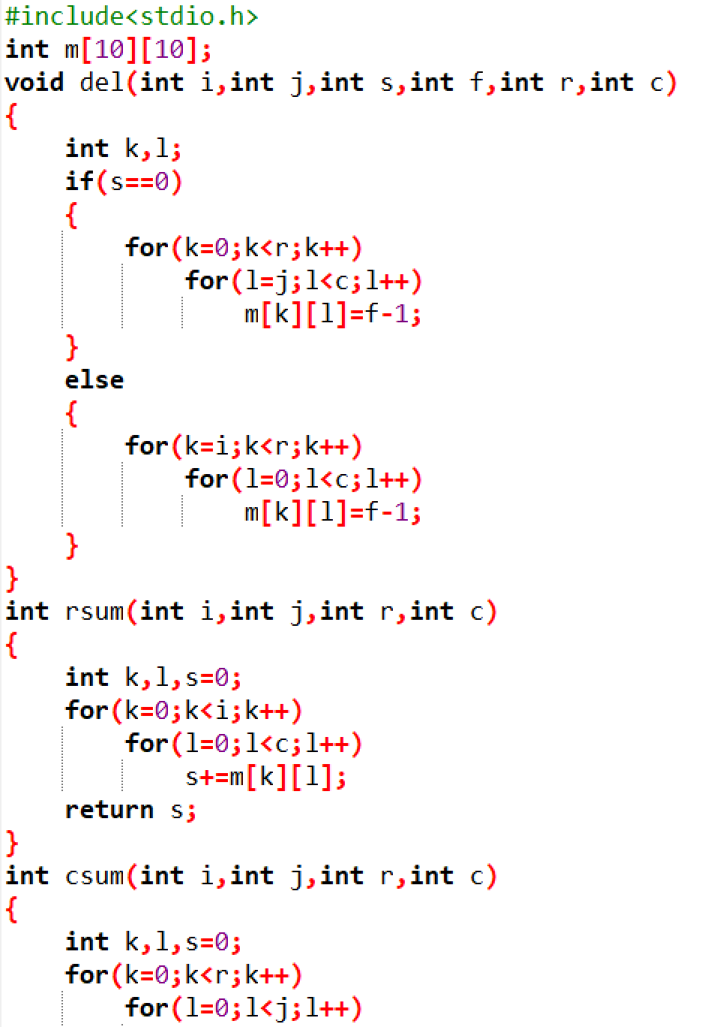

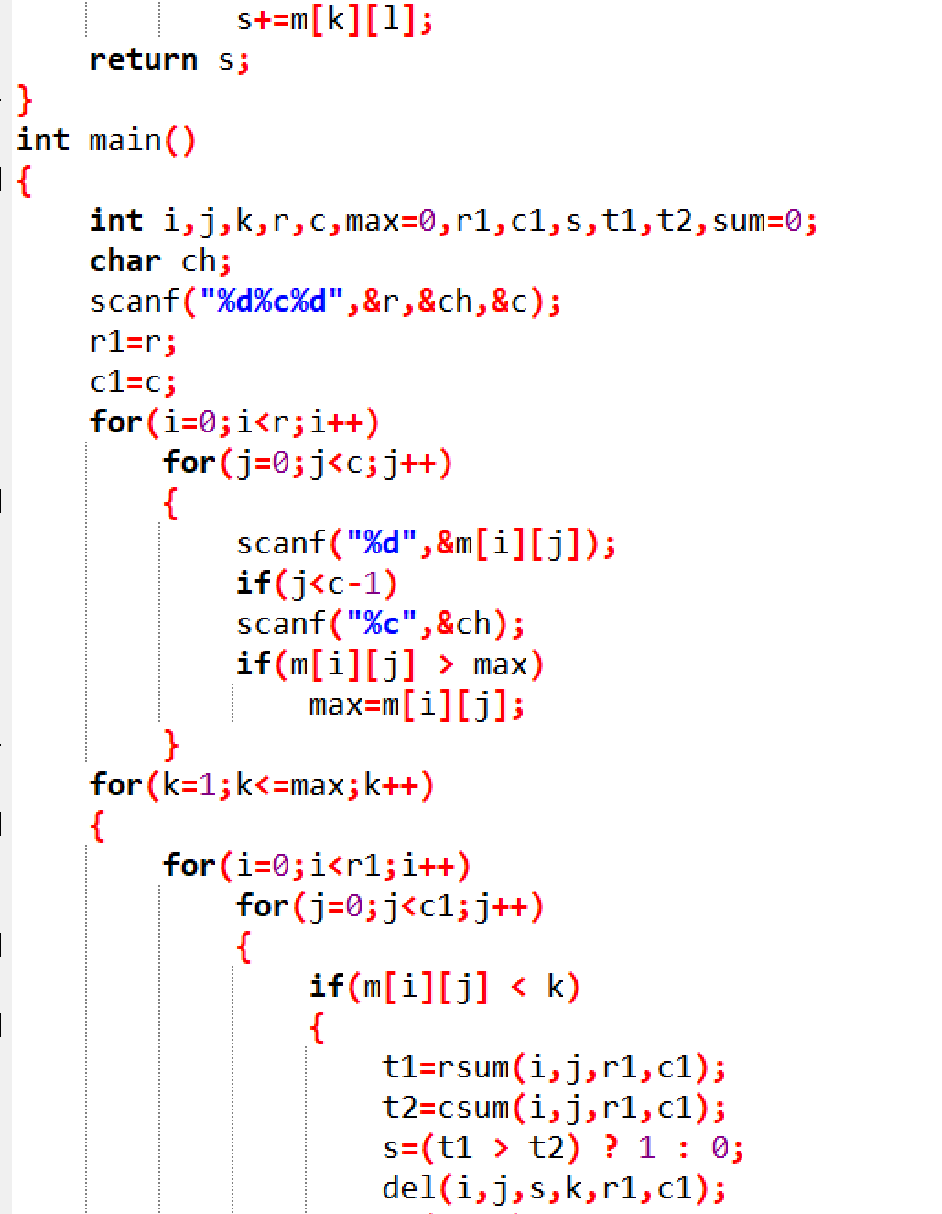

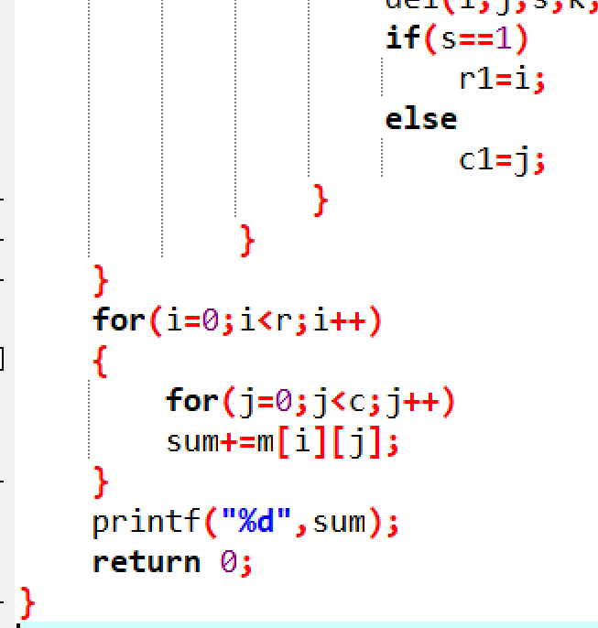

**Fig 6.2.1**

## 

## 6.3 OUTPUT :-

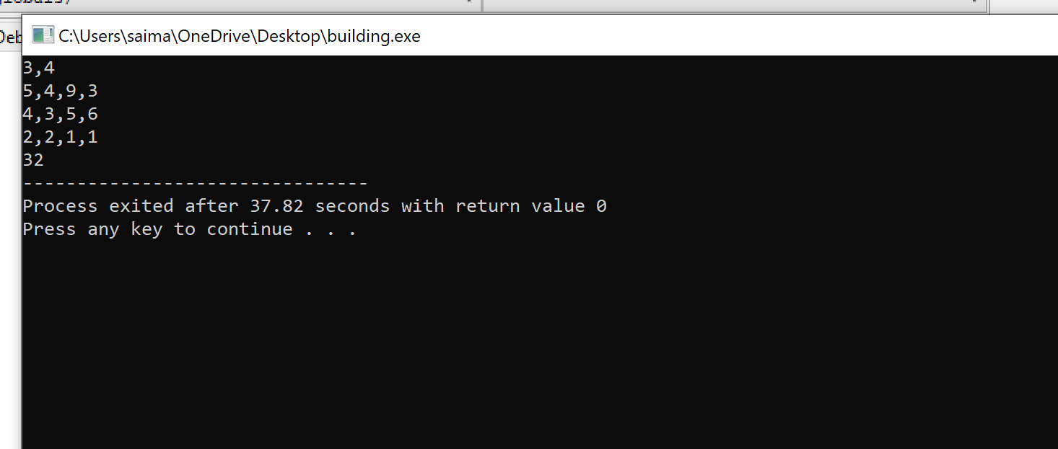

**Fig 6.3.1**

# 

# 

# 

# 

# 

# 

# 

# 

# 

# 

# 

# 

# 

# 

# 7. PROBLEM 6

**SUPER REDUCED STRING**

In this problem we are going to reduce the string to its shortest length by performing series of the operations and print it

## 7.1 Problem Statement:-

Steve has a string of lowercase characters in range ascii[‘a’..’z’]. He wants to reduce the string to its shortest length by doing a series of operations. In each operation he selects a pair of adjacent lowercase letters that match, and he deletes them. For instance, the string aab could be shortened to b in one operation. Steve’s task is to delete as many characters as possible using this method and print the resulting string. If the final string is empty, print Empty String Function Description

Complete the superReducedString function in the editor below. It should return the super reduced string or Empty String if the final string is empty.

superReducedString has the following parameter(s):

s: a string to reduce

**Input Format:**

A single string,s.

**Output Format:**

If the final string is empty, print Empty String; otherwise, print the final non-reducible string.

Sample Input 0

aaabccddd

Sample Output 0

abd

Explanation 0

Steve performs the following sequence of operations to get the final string:

aaabccddd → abccddd → abddd → abd

Sample Input 1

aa

Sample Output 1

Empty String

Explanation 1

aa → Empty String

Sample Input 2

baab

Sample Output 2

Empty String

Explanation 2

baab → bb → Empty String

**Concepts Used To Solve:-**

Character Array , Empty function()

**Character Array -** Character (char) is a primitive data type in C that is used to store a character value.

A string is a sequence of characters treated as a single entity and is terminated by a null character ('\0').

Example: char arr[] = "Hello World";

Empty function() - This function checks whether the string is empty or not. Function returns a Boolean value either true or false.

**Syntax**

Consider a string str. Syntax would be:

str.empty();

Parameter

This function does not contain any parameter.

Return value

It returns a Boolean value either 0 or 1 depending upon the conditions

## 7.2 Coding:-

## 

**Fig 7.2.1**

## 7.3 OUTPUT:-

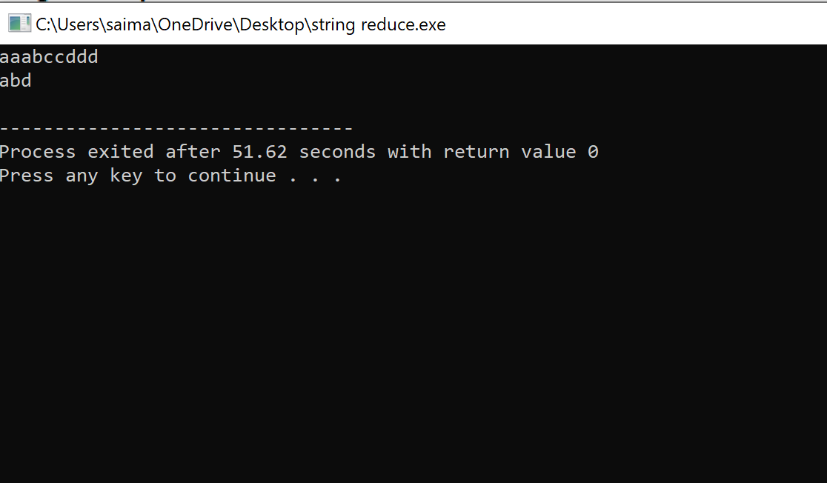

**Fig 7.3.1**

# 8. SOFTWARE REQUIREMENTS

## 8.1 Hardware Requirements:-

This project can be executed in any system or an android phone without prior to any platform.

We can use any online compiler and interpreter.

## 8.2 Software Requirements:-

There are two ways to execute this projects

1. Online compilers
2. Softwares applications for execution..,IDE’S(DEV C++)

**Online compilers** are tools which allows you to compile source code and execute it online in many programming languages. It's an online compiler and debugging tool which allows to compile and run code online

IDEs need to be installed based on the user’s system specification. These help us to completely execute the project. These softwares are based on the platforms. Many of them are free of cost.

Based on the availability we can use anyone.

Some of the best Online Compilers are:

OnlineGDB, Tutorial point, Programiz, Code chef and many more.

Some of the best Softwares for execution(IDE’s) are:

For C: Turbo C, DEV C++ etc.

**Dev-C++** is a free full-featured integrated development environment (IDE) distributed under the GNU General Public License for programming in C and C++.

**REFERENCES**

* [https://www.programminggeek.in](https://www.programminggeek.in/2016/07/TCS-CodeVita-Previous-years-questions.html#.Xx1Qd54zZPZ)
* [https://practice.geeksforgeeks.org](https://practice.geeksforgeeks.org/problems/x-total-shapes/0)
* [www.tcscodevita.com](http://www.tcscodevita.com)
* [https://www.hackerrank.com](https://www.hackerrank.com/challenges/reduced-string/problem)